National Register of Palliative Care Consumers and Carers

FACT SHEET
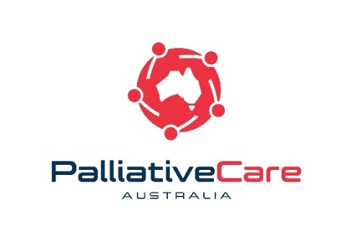
Palliative Care Australia (PCA) is the national peak body for palliative care. We represent all those who work towards high quality palliative care for all Australians. PCA truly believes in the important contributions palliative care consumers and carers can make to improve palliative care. This initiative has been established to give voice to the lived experience of palliative care in Australia with the ultimate goal of improving the quality of, and access to, palliative care throughout the country.
What is the National Register of Palliative Care Consumers and Carers?
The National Register is designed to foster opportunities for consumers and carers to engage in palliative care health policy, service delivery and reform activities on a national level.
How do you become a consumer representative?
Selection occurs through a review process on an annual basis (or as needed). The call for applications will be publicised through our e-newsletter and website. A panel of PCA employees will make the selection based on the skills, experience and commitment outlined in the application.
Who is eligible to be a consumer representative?
- Consumers - people receiving palliative care for a life-limiting illness
- Carers - people who have provided care in the past or are currently caring for a person receiving palliative care
- Family members of a person who has or is currently receiving palliative care
- Volunteers – people who have experience caring as a volunteer for a person receiving palliative care

How many consumer representatives are on the National Register?
In 2019, the National Register consists of six trained palliative care consumers and carers from across Australia. Eventually this will be increased to as many as 10 members.
*Reserve members are also selected through each membership review. The opportunity to be listed on the National Register will be made to reserve members when vacancies become available.
What specifically will consumer representatives do?
Our palliative care consumer and carer representatives use their lived experience, knowledge of the palliative care sector and communication skills to advocate for and promote the issues and concerns of palliative care consumers and carers.
Consumer representatives will:
- Participate in an initial induction training and annual workshop to gain skills and expertise in advocacy, policy development, communication to leverage experience with palliative care to improve the sector
- Represent consumer and carer issues on a national level, beyond personal experience on project engagement activities (Organisations may seek to have panel members involved in a number of different ways, including as a participant on national committee, advisor to a Board, member of a working group, or to conduct evaluations).
- Submit reports (verbal or written) following representative activities for data collection
- Work respectfully with fellow consumer representatives and the secretariat

What if a consumer representative is unwell or does not want to take part in a project?
Participation in individual opportunities is at the discretion of each consumer representative. If a consumer representative is unwell or believes they cannot contribute in a meaningful way they may chose not to participate or withdraw themselves. In these cases PCA will work with the organisation to identify another suitable consumer representative.
How long is the term for a consumer representative on the National Register?
There is no required term for participation, however we do encourage consumer representatives to remain on the National Register for a period of between one to five years.
Will consumer representatives get paid?
PCA will work with each organisation before the promotion of a project to ensure the conditions are reasonable. Project details will be shared with consumer representatives before the start of the project.

Sitting fees, travel, accommodation and project costs will be covered by the host organisation.

PCA will cover consumer representative's expenses related to attending the annual workshop. As the workshop is a training and development opportunity, sitting fees are not provided for attendance.

How will consumer representatives be paid?
Consumer representatives are encouraged to seek their own individual advice with respect to the taxation implications of receiving payments for contributions as a consumer representative. Payments to consumer representatives will only be made on the provision of either:
- A valid tax invoice which states the consumer representative's Australian Business Number; or
- A statement by a supplier which outlines the reason for not quoting an Australian Business Number.

PCA will provide support and guidance in applying for an ABN number, if desired.

Who do I contact if I have questions about the National Register?
If you have any questions about the panel please contact Tim van Ierschot, Community Engagement Coordinator, on 02 6232 0721 or tim@palliativecare.org.au.
Flexibility & Support
PCA acknowledges that some consumer representatives may face barriers inhibiting their participation in training, projects and travel, especially where they are currently receiving palliative care or are providing support for a person receiving palliative care. Accordingly, PCA will work with consumer representatives to ensure we are supportive and flexible to accommodate the diverse needs of each individual. This may include utilising video conferencing and other technology solutions.

