National Register of Palliative Care Consumers and Carers

FACT SHEET
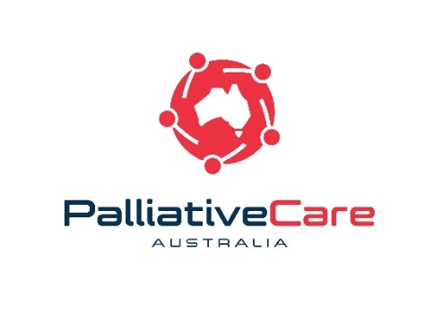
Palliative Care Australia (PCA) is the national peak body for palliative care. We represent all those who work towards high quality palliative care for all Australians. PCA truly believes in the important contributions palliative care consumers and carers can make to improve palliative care. This initiative has been established to give voice to the lived experience of palliative care in Australia with the ultimate goal of improving the quality of, and access to, palliative care throughout the country.
What is the National Register of Palliative Care Consumers and Carers?
The National Register is designed to foster opportunities for consumers and carers to engage in developing palliative care health policy, service delivery and reform activities on a national level.
How many consumer representatives are on the National Register?
In 2019, the National Register consists of six trained palliative care consumers and carers from across Australia. Eventually this will be increased to as many as 10 members. To find out more about our current members visit the website.
How can consumer representatives contribute to my project?
Our palliative care consumer and carer representatives use their lived experience, knowledge of the palliative care sector and communication skills to advocate for and promote the issues and concerns of palliative care consumers and carers.
Each consumer representative has received training to equip them with skills and expertise in advocacy, policy development and communication. Their objective is to represent consumer and carer issues on a national level, beyond their personal experience on project engagement activities, including as a participant on national committee, advisor to a Board, member of a working group, or to conduct evaluations.
How do I go about engaging a representative?
To engage one of our consumer representatives you will need to submit an application form (available from the PCA website) and either identify a specific individual(s) based on information in their online biography, or request a recommendation based on the requirements of your project.
The information you include in your application form will then be provided to the consumer representative(s) you nominate. Participation in a project is at the discretion of each individual consumer representative. If a consumer representative is unwell or believes they cannot contribute in a meaningful way they may choose to withdraw themselves from consideration. In these cases PCA will work with the organisation to identify another suitable consumer representative.
Once a representative opportunity has been confirmed, the consumer representatives contact information will be shared with you. Unless otherwise agreed, you will then need to make and manage project arrangements with the consumer representative you have engaged.

How much should consumer representatives be paid?
When you engage a consumer representative we ask that you cover their sitting fees, travel, accommodation and associated project costs. PCA will work with you prior to approaching consumer representatives to ensure the conditions are reasonable.

You are encouraged to pay consumer representatives in line with PCA's Remuneration Policy. PCA recommended participation payments are:
• $100 for half a day (up to four (4) hours)
• $200 for a full day (more than four (4) hours)

If you are unable to fund payment, a consumer representative may choose to take part in the project in an unfunded way, but this will be at their discretion. In certain instances PCA may provide a base payment in alignment with our remuneration policy.

How will consumer representatives be paid?
A template will be available to consumer representatives to allow them to provide you with a valid tax invoice stating their Australian Business Number. However, you may wish to negotiate with the consumer representative if you have alternative processes in place to facilitate payment.

What is Palliative Care Australia's role?
PCA will provide education and training opportunities, and self-care resources to assist consumer representatives carry out their roles efficiently and effectively. PCA will also work with, and provide administrative and project support to consumer representatives in order to identify and allocate engagement opportunities. However, once you have engaged with a consumer representative, you are encouraged to negotiate and communicate directly with your representative.

If required, where issues arise PCA will work with you and the consumer representative to help resolve any issues, provide support and determine the best way forward.

What information do I need to share with Palliative Care Australia regarding outcomes of my project?
Once your project is completed, you will be asked to complete an evaluation of your engagement with the consumer representative, and the outcomes you were able to achieve with their participation. The consumer representative will also be asked to complete an evaluation, outlining the extent of their engagement with your project, with a view to help us improve the program in the future.

Who do I contact if I have questions about the National Register?
If you have any questions about the panel please contact Tim van Ierschot, Community Engagement Coordinator, on 02 6232 0721 or tim@palliativecare.org.au.

