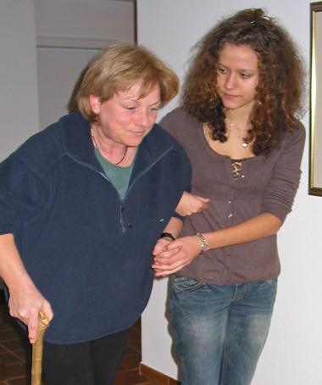
8 October is World Hospice and Palliative Care Day…..
BUT what do we mean by hospice?
Here are 10 things you need to know about hospice
3
1
Hospice is both an approach to end-of-life care and a place
Hospice is high-quality care that focuses on comfort and quality of life, which may be provided at home, in a hospital, a nursing home, or in a facility specifically designated for such service. The ultimate goal of hospice is to provide comfort, manage symptoms, and preserve patient dignity for people with a life-limiting illness.

2
Hospice does not only provide care for people with cancer
It’s a myth that hospices = cancer care. Hospices provide care for anyone with a life-limiting illness, including degenerative conditions like motor neurone disease, kidney disease and heart disease. Staff including occupational therapists, physiotherapists, and social workers help patients adapt their homes and conditions in order to stay independent for as long as possible.

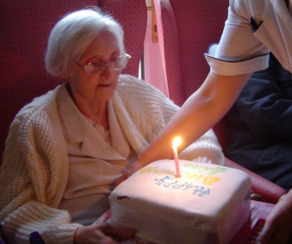
Hospice is for anyone with a life-limiting illness, regardless of age
People often think that hospices are the same as nursing homes for older people, but they care for people of all ages.

Hospice intends neither to hasten nor postpone death
However, research has shown people receiving hospice care can live longer than similar patients who do not opt for hospice.

5
4
More care, not less
Families and patients are often worried that receiving support from hospice or palliative care means they are giving up. This is not true. It is about providing an extra layer of support, and ensuring good symptom management so that people can live as well as possible, right until the end of their lives.

KEEP READING
KEEP READING
6
Many hospices organise for therapy pets to come in to visit patients and comfort families
The most infamous therapy pet in Canberra is Honeycomb, the alpaca. Honeycomb, who died early this year, was just a few weeks old when he started visiting Clare Holland House, a local hospice, bringing a smile to residents there.

Many different people and professions are at work in a typical hospice
“You work at a hospice? Oh, what’s it like being a nurse?” Actually, physicians, nurses, social workers, spiritual counselors, clinical pharmacists, bereavement counsellors, occupational therapists, art therapists and others are all part of the palliative care team. Team members coordinate care and share patient details. A social worker, for example, will inform physicians and nurses about a patient’s previously undetected emotional or spiritual distress to provide further help.

9
Some patients get to go home again
Everyone accessing hospice services or living at a hospice facility has an incurable illness, but not everyone who goes to a hospice is going to die there. Sometimes people are admitted for a few days to help get their symptoms under control, then they go back home.

8
Hospice helps patients achieve their final wishes and goals
Many hospice teams are keen to help patients achieve any last ‘ticks’ on their bucket list, from arranging medical equipment so a patient can go on holiday or phoning a favourite restaurant to book a patient and their family for dinner.

7

10
There is such thing as a ‘good death’
Hospice and palliative care is care that helps people live their life as fully and as comfortably as possible when living with a life-limiting illness. What a good death looks like will be different depending on the person. But for many it will include being afforded dignity, good pain and symptom control and being with close family and friends.

References
1. Nabili SN. Hospice Facts [Internet]. Medicine Net. 2016 [cited 2016 Sep 28]. Available from: http://www.medicinenet.com/hospice/article.htm
2. Organization NH and PC. Ten Facts about Hospice Care You May Not Know [Internet]. 2013 [cited 2016 Sep 28]. Available from: http://www.nhpco.org/press-room/press-releases/ten-facts-about-hospice-care-you-may-not-know
3. Mitchell H. 24 Deeply Honest Confessions From A Hospice Worker [Internet]. BuzzFeed. 2016 [cited 2016 Sep 28]. Available from: https://www.buzzfeed.com/hilarywardle/secrets-hospice-workers-wont-tell-you?utm_term=.esAZ03xDwe#.bhyEZw0o2M
4. Organization WH. WHO Definition of Palliative Care [Internet]. World Health Organization. 2016 [cited 2016 Sep 30]. Available from: http://www.who.int/cancer/palliative/definition/en/
5. Doherty M. Honeycomb the alpaca, friend to the sick, lonely and dying has passed away. The Canberra Times [Internet]. 2016; Available from: http://www.canberratimes.com.au/act-news/canberra-life/honeycomb-the-alpaca-friend-to-the-sick-lonely-and-dying-has-passed-away-20160728-gqfnbh.html
6. Carers ACT A. Fast Facts on Disability, Mental Health and Carers [Internet]. Carers ACT Website. 2016 [cited 2016 Sep 30]. Available from: http://www.carersact.org.au/Assets/Files/Carers ACT Fast Facts September 2016 PDF[1].pdf

